**Mohammed Mahin Ibnay Mamun (346584)**

**Pizza python code 2019 paper**

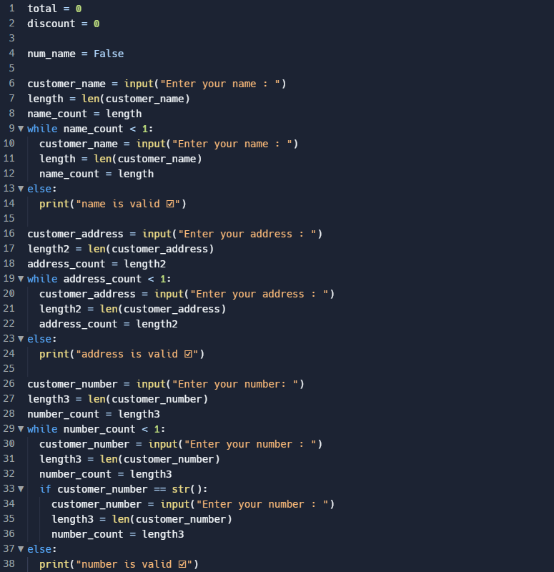

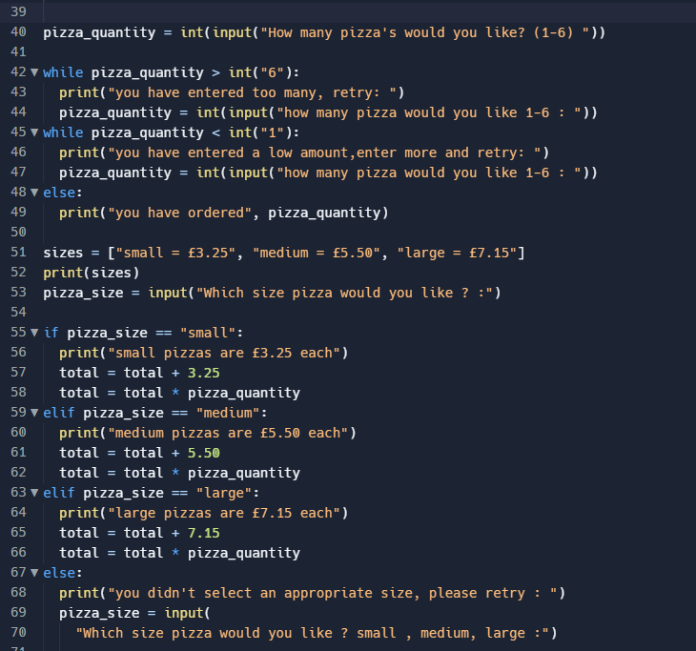

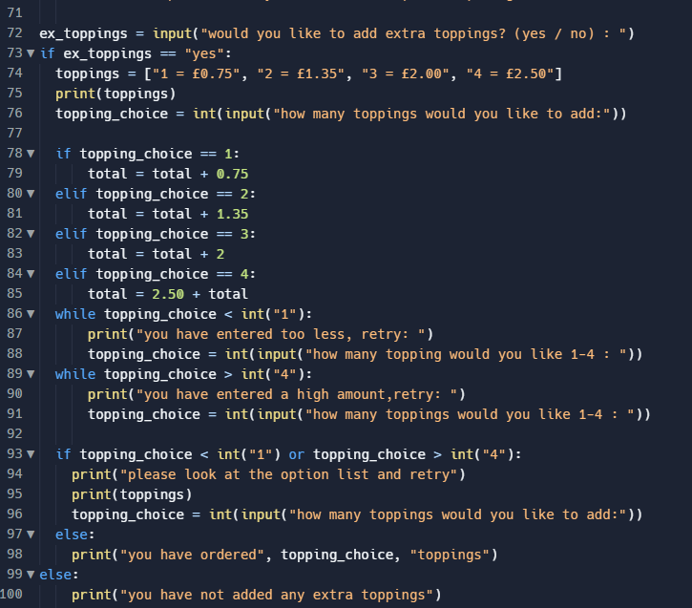

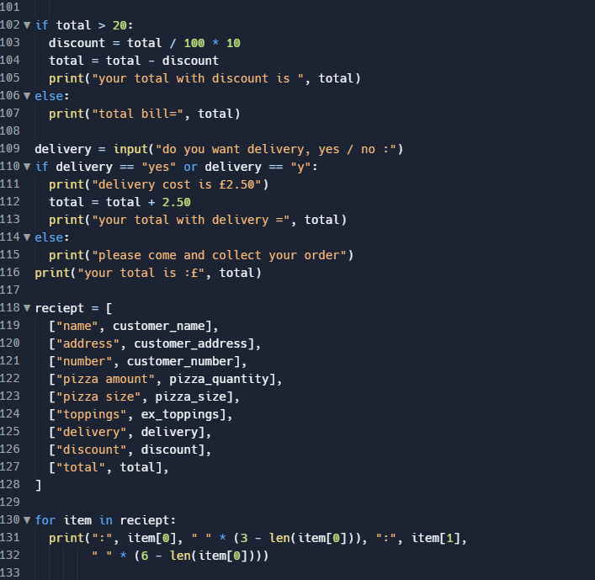

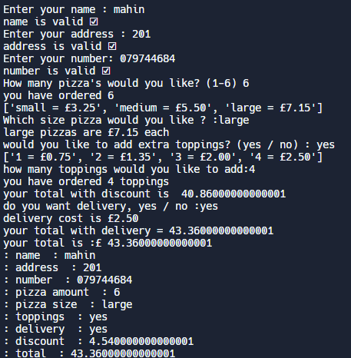

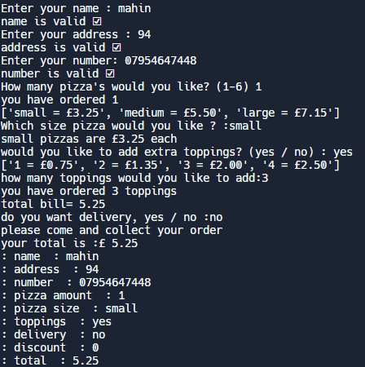

total = 0

discount = 0

num_name = False

customer_name = input("Enter your name : ")

length = len(customer_name)

name_count = length

while name_count < 1:

customer_name = input("Enter your name : ")

length = len(customer_name)

name_count = length

else:

print("name is valid ☑")

customer_address = input("Enter your address : ")

length2 = len(customer_address)

address_count = length2

while address_count < 1:

customer_address = input("Enter your address : ")

length2 = len(customer_address)

address_count = length2

else:

print("address is valid ☑")

customer_number = input("Enter your number: ")

length3 = len(customer_number)

number_count = length3

while number_count < 1:

customer_number = input("Enter your number : ")

length3 = len(customer_number)

number_count = length3

if customer_number == str():

customer_number = input("Enter your number : ")

length3 = len(customer_number)

number_count = length3

else:

print("number is valid ☑")

pizza_quantity = int(input("How many pizza's would you like? (1-6) "))

while pizza_quantity > int("6"):

print("you have entered too many, retry: ")

pizza_quantity = int(input("how many pizza would you like 1-6 : "))

while pizza_quantity < int("1"):

print("you have entered a low amount,enter more and retry: ")

pizza_quantity = int(input("how many pizza would you like 1-6 : "))

else:

print("you have ordered", pizza_quantity)

sizes = ["small = £3.25", "medium = £5.50", "large = £7.15"]

print(sizes)

pizza_size = input("Which size pizza would you like ? :")

if pizza_size == "small":

print("small pizzas are £3.25 each")

total = total + 3.25

total = total * pizza_quantity

elif pizza_size == "medium":

print("medium pizzas are £5.50 each")

total = total + 5.50

total = total * pizza_quantity

elif pizza_size == "large":

print("large pizzas are £7.15 each")

total = total + 7.15

total = total * pizza_quantity

else:

print("you didn't select an appropriate size, please retry : ")

pizza_size = input(

"Which size pizza would you like ? small , medium, large :")

ex_toppings = input("would you like to add extra toppings? (yes / no) : ")

if ex_toppings == "yes":

toppings = ["1 = £0.75", "2 = £1.35", "3 = £2.00", "4 = £2.50"]

print(toppings)

topping_choice = int(input("how many toppings would you like to add:"))

if topping_choice == 1:

total = total + 0.75

elif topping_choice == 2:

total = total + 1.35

elif topping_choice == 3:

total = total + 2

elif topping_choice == 4:

total = 2.50 + total

while topping_choice < int("1"):

print("you have entered too less, retry: ")

topping_choice = int(input("how many topping would you like 1-4 : "))

while topping_choice > int("4"):

print("you have entered a high amount,retry: ")

topping_choice = int(input("how many toppings would you like 1-4 : "))

if topping_choice < int("1") or topping_choice > int("4"):

print("please look at the option list and retry")

print(toppings)

topping_choice = int(input("how many toppings would you like to add:"))

else:

print("you have ordered", topping_choice, "toppings")

else:

print("you have not added any extra toppings")

if total > 20:

discount = total / 100 * 10

total = total - discount

print("your total with discount is ", total)

else:

print("total bill=", total)

delivery = input("do you want delivery, yes / no :")

if delivery == "yes" or delivery == "y":

print("delivery cost is £2.50")

total = total + 2.50

print("your total with delivery =", total)

else:

print("please come and collect your order")

print("your total is :£", total)

reciept = [

["name", customer_name],

["address", customer_address],

["number", customer_number],

["pizza amount", pizza_quantity],

["pizza size", pizza_size],

["toppings", ex_toppings],

["delivery", delivery],

["discount", discount],

["total", total],

]

for item in reciept:

print(":", item[0], " " * (3 - len(item[0])), ":", item[1],

" " * (6 - len(item[0])))